Post-9/11 Veterans Organizations

The leading community-based, Post-9/11 Veterans Organizations are Student Veterans of America (SVA), Team Red, White and Blue (RWB), Mission Continues, Wounded Warrior Project, and Team Rubicon. These organizations are different from traditional Veterans Service Organizations (VSOs) in that they focus more on local engagement and community-based programs. They also don’t have a large DC presence and rely heavily on regional paid staff and volunteers to operate programs and chapters.

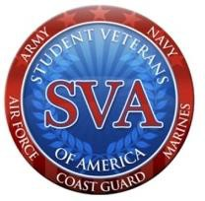

SVA focuses on higher education. They help transitioning Service members and Veterans make informed educational decisions about college and the GI Bill, provide support to Veterans in college through 1,000+ on-campus chapters, and assist Veterans seeking employment after college. [Explore SVA chapters](http://studentveterans.org/chapter/directory).

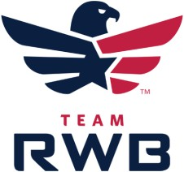[Team RWB](http://www.teamrwb.org/) focuses on local, consistent community engagement and physical fitness. They connect Veterans to their community through physical fitness events, community service projects, and social activities in over 140 communities. They use a regional model with full-time staff throughout the country managing their chapters. [Find local Team RWB chapters](https://www.teamrwb.org/chapter-locations).

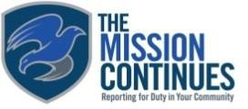[Mission Continues](https://www.missioncontinues.org/) empowers Veterans adjusting to life at home to find purpose through community impact that is focused on community service projects. They use a regional model with full-time staff in larger cities throughout the country. Members join one of 40+ “service platoons” to contribute to community projects, gain skills, and build relationships. [Locate Mission Continues service platoons](https://www.missioncontinues.org/service-platoons/).

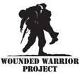[Wounded Warrior Project](https://www.woundedwarriorproject.org/) provides opportunities for wounded Veterans to improve their lives through various physical and mental health programs. They help fund some of the other Veterans organizations and have more paid staff than any other group. [Access Wounded Warrior Project offices and locations](https://www.woundedwarriorproject.org/contact-us).

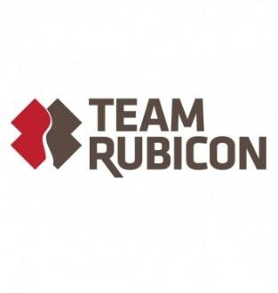[Team Rubicon](http://teamrubiconusa.org/) leverages Veteran and first responder skills and experience to help communities in need. While not responding to disasters, they host training and community improvement events. Their paid staff is aligned to the FEMA district model. [Learn more about their organizational structure](http://teamrubiconusa.org/story-of-team-rubicon/regions/).

[Got Your 6](https://gotyour6.org/about/who-we-are/) is a campaign that unites nonprofit, Hollywood, and government partners. They portray Veterans in a positive way and as civic assets that help our nation and communities. They don’t execute local programs; however, they lead a coalition of other Veteran organizations.

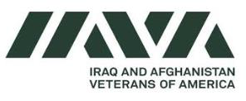

[Iraq and Afghanistan Veterans of America](http://iava.org/) empowers and advocates for Veterans and partner with VA on mutual interests. They facilitate local “Vet Togethers” for Veterans to meet one another.