Traditional Veterans Service Organizations

There are over 100 VA-recognized, national Veterans Service Organizations (VSOs), and VA works most closely with the following organizations: The American Legion, Veterans of Foreign Wars, Disabled American Veterans, Paralyzed Veterans of America, American Veterans (AMVETS), and Vietnam Veterans of America. No two VSOs are the same, but these organizations have two things in common: They help Veterans navigate the VA claims and benefits system, and they help Veterans connect and live fulfilling lives through their local facilities and programs. These organizations have Washington, DC, offices that advocate for Veterans.

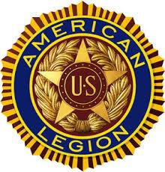

[The American Legion](http://www.legion.org/) is committed to promoting patriotism and supporting Veterans through local community programs. They operate over 10,000 posts, and, as the largest VSO, they support over 2.3 million members. They are organized by Departments (states) and local districts (posts). [Access American Legion locations and local leadership](http://www.legion.org/departments).

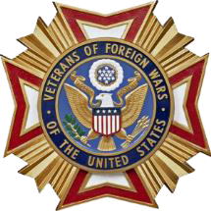

[Veterans of Foreign Wars](http://www.vfw.org/about-us) aims to foster camaraderie among United States Veterans of overseas conflicts; serve Veterans, the military, and our communities; and advocate on behalf of all Veterans. They operate over 4,000 posts throughout the country.   
[Find a local VFW](http://www.vfw.org/find-a-post).

[Disabled American Veterans](https://www.dav.org/learn-more/about-dav/mission-statement/) (DAV) supports disabled Veterans of all generations and their families by empowering them to lead high-quality lives with respect and dignity. DAV provides claims support and more than 700,000 rides for Veterans attending medical appointments. [Find a local DAV chapter](https://www.dav.org/membership/local-chapters/).

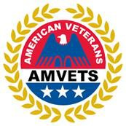

[AMVETS](http://www.amvets.org/about/) enhances and safeguards entitlements for all American Veterans who have served honorably and aims to improve the quality of life for Veterans, their families, and the communities where they live through leadership, advocacy, and services. [Search 1,400 AMVETS locations](http://www.amvets.org/amvets-near-you/) throughout the country.

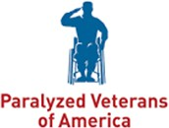

[Paralyzed Veterans of America](http://www.pva.org/) aims to change lives and build brighter futures for seriously injured Veterans and is dedicated to Veteran service, medical research, and civil rights for people with disabilities. There are [72 National Service Offices and 32 chapters](http://www.pva.org/site/c.ajIRK9NJLcJ2E/b.6452325/k.A0ED/Chapters_and_NSOs.htm) that help empower Veterans.

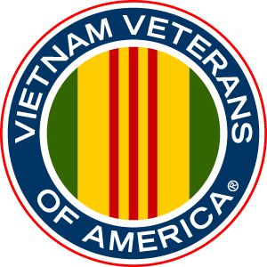

[Vietnam Veterans of America](https://vva.org/who-we-are/about-us-history/) supports the full range of issues important to Vietnam Veterans to create a new identity for this generation of Veterans and change public perception. Their motto: “Never again will one generation of Veterans abandon another.” [Explore Vietnam Veterans of America locations](https://vva.org/what-we-do/our-members/chapters/).